Tab 1

Details
- Name: Syrena
- Age: 25
- Gender/Pronouns: Female (She/Her
- Class: Druid
- Subclass:
- Race: Dragonborn
- Background: Venatrix
- Divine Connection (if applicable):
- Familiar (if applicable)
Appearance

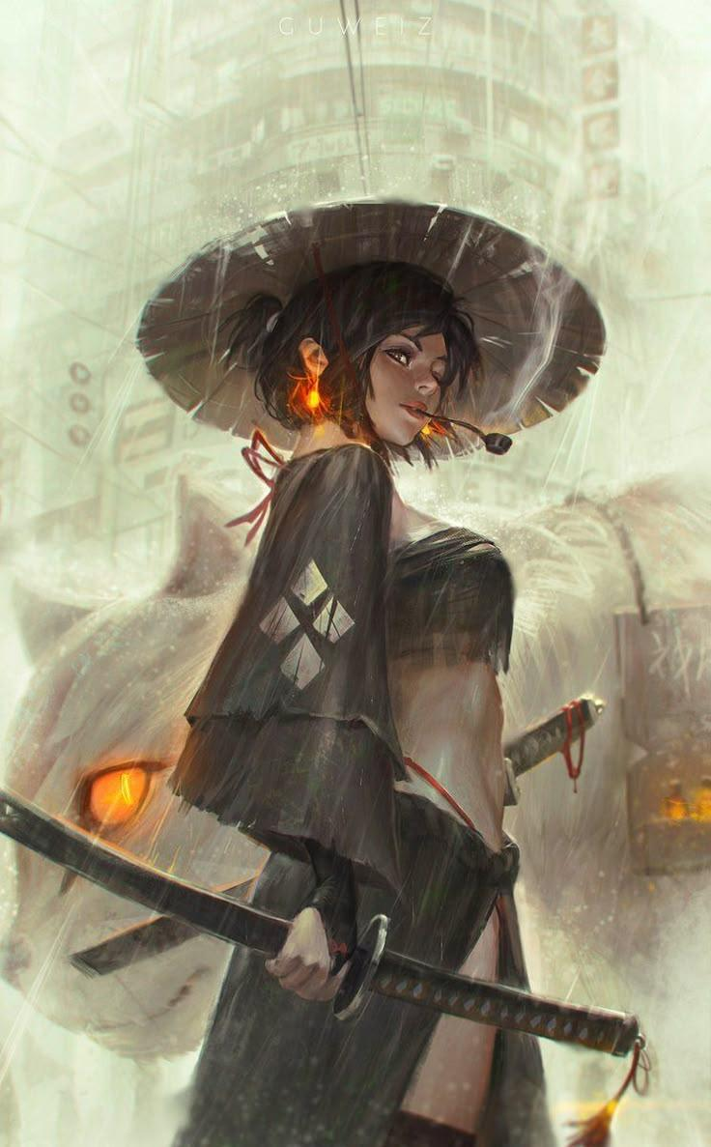
- Hair: Black (shoulder-length)
- Eyes: Hazel
- Skin: Tanned
- Build: Toned, scarred but smooth skin
- Height: 160cm
- Clothing Style (What do they usually wear?): Traditional Thai outfits

Personality
- On the Outside (How do others perceive them initially?): Aggressive, scary, dangerous, unapproachable
- On the Inside (What are their true feelings or hidden traits?): Do no harm but take no shit
- Quirks: Likes to challenge the group to do something risky. Likes to compete.
- Voice and Mannerisms (Accents, typical gestures, etc.): Brutal honesty, spiteful words, woman of a few words.
- Daily/Little Habits: Perceive dangerous creatures as cute, especially the tiny ones. And wants to tame them.

Goals and Stakes
- Short-term Goals (What do they want to achieve right now?): Taming the strongest creatures and make them her protectors
- Long-term Goals (What is their ultimate ambition?): Build a safe haven where she rules with her creatures and protect people who seek sanctuary
- Stakes (What do they stand to lose? Who or what is most important to them?): The most important thing she can lose is herself, everything else is temporary

Backstory
- Personal Backstory (The full details of their past):
Syrena is the 11th child out of 24, of an infamous Dragonborn noble from Aries city. She never knew her biological mother. None of her half siblings do, each one had a different mother so the house was filled with children of diverse mixed races. Syrena's bastard father was a pervert; she and her siblings assumed that his dozens of wives died from giving birth to them or from suffering his wrath.
Growing up, Syrena and her siblings were abused and trained past their limits to become the best experts their own bloodline has to offer because their father was greedy and desperate to build his own empire. He wanted to be the fifth region where he is the only king amongst all kingdoms. There is a hidden motive behind this.
She and her siblings despise him. Their childhood was destroyed by his torture and expectations. Their futures were decided and controlled by him. Their father was infamous for being a shitty narcissistic dictator. Even though he didn't rule an empire yet, he was a rich enough noble who owned a single land and controlled everyone living there. He uses all his 24 children to do his bidding and build his empire for him.
One day, when his land was attacked by riots (dissatisfied citizens who were treated harshly under his rule), Syrena and a few of her siblings managed to escape but got separated when they were being chased by the rioters.
Syrena decided that in order to survive, she wasn't going to give anyone the chance to hurt, control, manipulate and use her like her ugly sperm donor did. Therefore, she releases all her pent up childhood trauma in the form of anger so no one would even think about messing with her. She escaped to Cancer and sought refuge there. But she doesn't stay in one place for too long because her disgusting ass father had been sending assassins to find her. Some of those assassins and mercenaries going after her are her own siblings (those who never got to leave). They are equally as violent and skillfully trained as she is. She needed to earn money for living expenses but the only thing she knew how to do that was to compete in the secret underground fighting rings. That's how she became a Venatrix. She hated fighting, it was what her father expected of her. Ironically, that's the only best asset she currently has to survive on her own. For now. Syrena kept moving from one place to another until she found the group. The main story takes place a few months after she escaped.
- Their Effluence (What form of emotional expression channels their magic?)
- Motivation for Joining (Why are they adventuring with this specific group? Leave this till instructed to add):

Group Dynamics
- Skills and Value to the Group (What role do they fill?): Healer, fighter, can communicate and tame creatures (so she won’t be easily killed by them and can protect weaker teammates), she can purify food so dumb people don’t get poisoned and die. Get the group moving towards challenging paths to get closer to their ultimate goals.

Tab 2

Details
- Name: Luna Liberta
- Age: 23
- Gender/Pronouns: Female (She/Her)
- Class: Bard
- Subclass:
- Race: High Elf
- Background: Wandering Performer
- Divine Connection (if applicable):
- Familiar (if applicable): A Cat plushie (Birmie - after the birman breed) - bright colored plushies that transform into different forms of big Cats depending on the situation

Appearance
- Hair: Long Silky Dark Black
- Eyes: Gray
- Skin: light
- Build: Fit, and Mummy
- Height: 2m
- Clothing Style (What do they usually wear?): Dark gothic tight fit suit, with Raven’s feathers
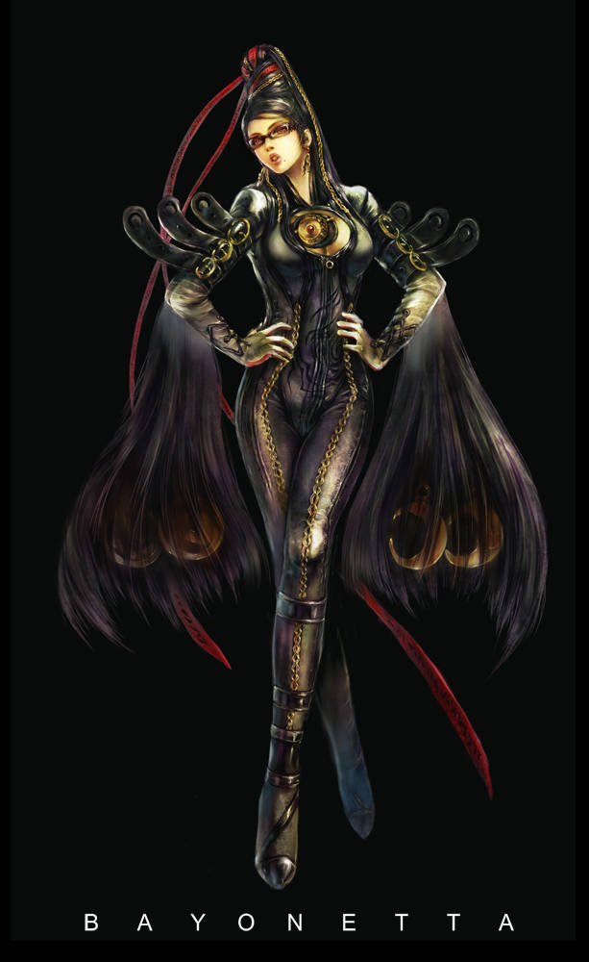

Personality
- On the Outside (How do others perceive them initially?): Intimidating when Sober, Fun when drunk
- On the Inside (What are their true feelings or hidden traits?): TMI
- Quirks:
- Voice and Mannerisms (Accents, typical gestures, etc.): Refer to bayonetta
- Daily/Little Habits: Refer to bayonetta

Goals and Stakes
- Short-term Goals (What do they want to achieve right now?): Explore each region’s culture and performs
- Long-term Goals (What is their ultimate ambition?): TMI
- Stakes (What do they stand to lose? Who or what is most important to them?): TMI

Backstory
- Personal Backstory (The full details of their past):
Most people know me only by my stage name, Luna Liberta. I'm a wandering bard who left the autumn region known as The Bleed to see what lies beyond its borders. Every town has its own stories, every culture its own songs, and every traveler another tale worth hearing. I make my living performing in taverns, festivals, and bustling streets, trading music for coin, food, and a place to rest. The road is my home now, and I travel simply because I want to understand how people live in lands unlike my own. One day, perhaps, I'll have enough stories to write a song that captures the whole world.
- Their Effluence (What form of emotional expression channels their magic?)
- Motivation for Joining (Why are they adventuring with this specific group? Leave this till instructed to add):

Group Dynamics
- Skills and Value to the Group (What role do they fill?):

Tab 3

Tab 4

Campaign World Overview

Magic System
- Emotional Channeling: Magic is channeled through performance, music, and illustration.
- Alignment: Magic fueled by love is considered good, while hate is considered evil.
- Illicit Magic: Those who manufacture magic through illicit means due to emotional incapacity are considered the filth of humanity.
- Protective Barriers: Cities are protected by musical barriers that play Vivaldi's Four Seasons in accordance with the current time of year.

World Concept
- The Pantheon: The Gods are named after the 13 zodiacs. They lack distinct races but physically resemble their constellations.
- Zodiac Cities: Each zodiac corresponds to a city residing in its proper season.
- Bestiary: All D&D monsters exist within this realm.

Regions & Governance
- The Awakening (Spring): Ruled by an Elf Queen. (Aries, Taurus, Gemini)
- The Zenith (Summer): Ruled by a Tiefling Queen. (Cancer, Leo, Virgo)
- The Bleed (Autumn): Ruled by a Half-Orc Queen. (Libra, Scorpio, Sagittarius)
- The Rime (Winter): Ruled by a Drow Queen. (Capricorn, Aquarius, Pisces)
- High Sovereignty: All four seasons are ultimately ruled by Lord Ophiuchus, the 13th God.

Protectors of the Realm
- Venatrix/Venator: Capable warriors who protect the lands through the mastery and control of their emotions.

Epiphany

Organizations

-Hostile

-Neutral

-Good

Characters

